Task 1:

<!DOCTYPE html>

<html>

<head>

<title>JavaScript &amp; jQuery - Chapter 7: Introducing jQuery - Event Object</title>

<link rel="stylesheet" href="css/c07.css" />

</head>

<body>

<div id="page">

<h1 id="header">List</h1>

<h2>Buy groceries</h2>

<ul>

<li id="one" class="hot"><em>fresh</em> figs </li>

<li id="two" class="hot">pine nuts</li>

<li id="three" class="hot">honey</li>

<li id="four">balsamic vinegar</li>

</ul>

</div>

<script src="js/jquery-1.11.0.js"></script>

<script>

var days = ["Sunday","Monday","Tuesday","Wednesday","Thursday","Friday","Saturday"];

var months = ["Jan","Feb","Mar","Apr","May","June","July","Aug","Sept","Oct","Nov","Dec"];

$(function(){

$('li').click(function(){

var date = new Date();

$(this).append('<span class="date">'+ "Clicked on " + days[date.getDay()] + " " + months[date.getMonth()] + " " + date.getDate() + " " +

+ date.getFullYear() + " at " + date.getHours() + ":" + date.getMinutes() + ":" + date.getSeconds() + '</span>');

});

});

</script>

</body>

</html>

**Output:**

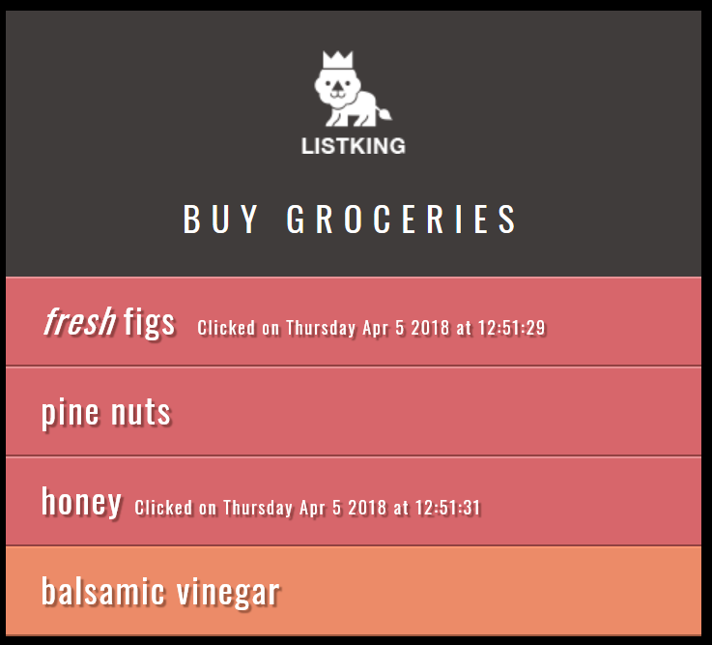

**Task 2:**

<!DOCTYPE html>

<html>

<head>

<title>JavaScript &amp; jQuery - Chapter 7: Introducing jQuery - Event Object</title>

<link rel="stylesheet" href="css/c07.css" />

</head>

<body>

<div id="page">

<h1 id="header">List</h1>

<h2>Buy groceries</h2>

<ul>

<li id="one" class="hot"><em>fresh</em> figs </li>

<li id="two" class="hot">pine nuts</li>

<li id="three" class="hot">honey</li>

<li id="four">balsamic vinegar</li>

</ul>

<p></p>

</div>

<script src="js/jquery-1.11.0.js"></script>

<script>

var status = {one:"Important", two:"Very Important",

three:"Not Important", four:"Regular"};

$(function(){

$('li').click(function(){

$('p').html("Item: " + $(this).text() + "<br/>Status: " +

status["" + $(this).attr("id")] + "<br/>Event: click");

});

$('li').mouseover(function(){

$('p').html("Item: " + $(this).text() + "<br/>Status: " +

status["" + $(this).attr("id")] + "<br/>Event: Mouseover");

});

});

</script>

</body>

</html>

**Output:**

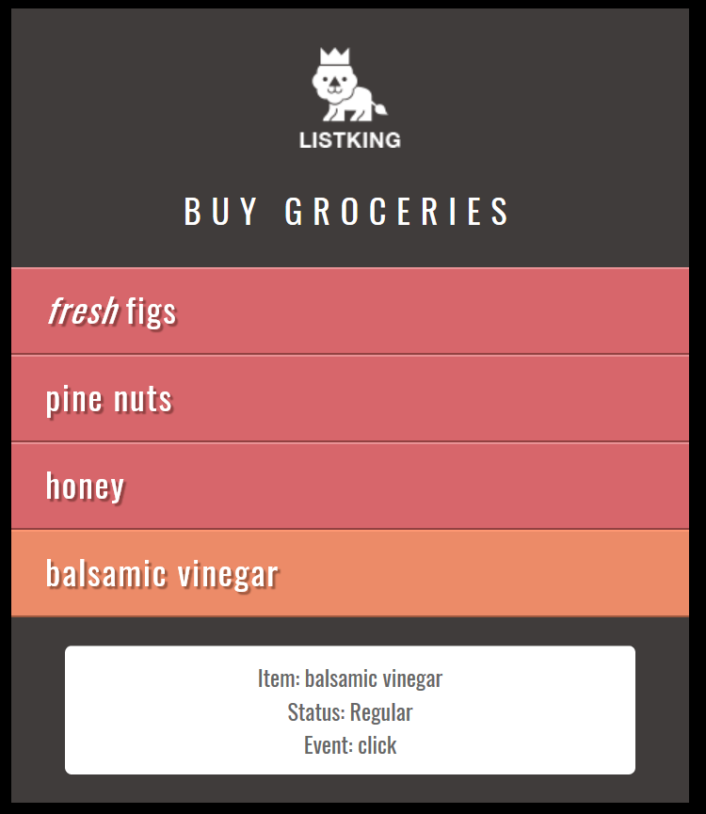

Task 3:

<!DOCTYPE html>

<html>

<head>

<title>JavaScript &amp; jQuery - Chapter 7: Introducing jQuery - Event Object</title>

<link rel="stylesheet" href="css/c07.css" />

</head>

<body>

<div id="page">

<h1 id="header">List</h1>

<h2>Buy groceries</h2>

<ul>

<li id="one" class="hot"><em>fresh</em> figs </li>

<li id="two" class="hot">pine nuts</li>

<li id="three" class="hot">honey</li>

<li id="four">balsamic vinegar</li>

<li id="four">linguine</li>

<li id="four">cream</li>

<li id="four">coconut milk</li>

<li id="four">mushrooms</li>

<li id="four">apples</li>

<li id="four">strawberries</li>

<li id="four">rice crackers</li>

<li id="four">brie</li>

<li id="four">rice</li>

<li id="four">green tea</li>

<li id="four">coconut vine-ripened tomatoes</li>

<li id="four">bananas</li>

<li id="four">red kidney beans</li>

<li id="four">baricot beans</li>

<li id="four">lettuce</li>

<li id="four">organic brown rice vinegar</li>

<li id="four">sushi nori</li>

<li id="four">garlic</li>

<li id="four">red onions</li>

<li id="four">goat's cheese</li>

<li id="four">baby leaf spinach</li>

<li id="four">coconut</li>

<li id="four">avocado</li>

<li id="four">leeks</li>

<li id="four">carrots</li>

<li id="four">pears</li>

<li id="four">apples</li>

<li id="four">organic free-range eggs</li>

<li id="four">cashew not buffer</li>

<li id="four">lemons</li>

<li id="four">coconut oil</li>

<li id="four">sourdough bread</li>

<li id="four">almond milk</li>

<li id="four">kale</li>

<li id="four">gluten-free soy sauce</li>

<li id="four">quinoa</li>

</ul>

<br/>

<div id="footer"> ListKing </div>

<br/>

</div>

<div style="position: fixed; right:1px; bottom:1px;" id="slideAd"> Buy ListKing Pro<br/> for Only $1.99 </div>

<script src="js/jquery-1.11.0.js"></script>

<script>

$(function(){

var range = $('#footer').offset().top - $(window).height() - 500;

var vertical = $(window).scrollTop();

if (range - vertical <= 500){

$('#slideAd').show();

}

else

{

$('#slideAd').hide();

}

$(window).scroll(function(){

range = $('#footer').offset().top - $(window).height() - 500;

vertical = $(window).scrollTop();

if (range - vertical <= 500){

$('#slideAd').fadeIn(500);

}

else

{

$('#slideAd').fadeOut(500);

}

});

});

</script>

</body>

</html>

**Output:**

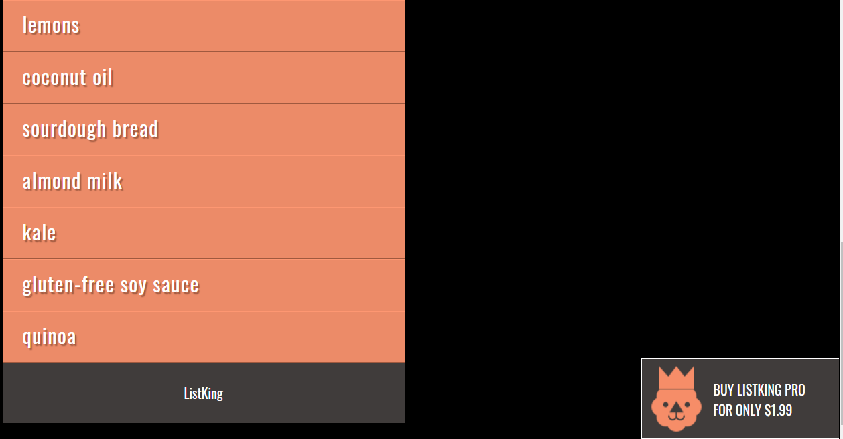

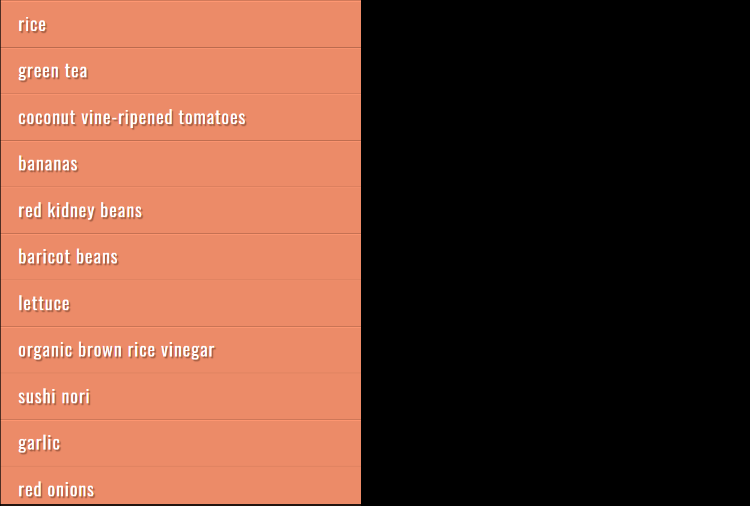

**Task 4:**

**Code:**

<!DOCTYPE html>

<html lang="en">

<head>

<meta charset="utf-8">

<title>jQuery Add / Remove Table Rows Dynamically</title>

<style type="text/css">

form{

margin: 20px 0;

}

form input, button{

padding: 5px;

}

table{

width: 100%;

margin-bottom: 20px;

border-collapse: collapse;

}

table, th, td{

border: 1px solid #cdcdcd;

}

table th, table td{

padding: 10px;

text-align: left;

}

</style>

<script src="js/jquery-1.11.0.js"></script>

<script type="text/javascript">

$(document).ready(function(){

$(".add-row").click(function(){

console.log("Ali");

console.log($("#name").val());

if ((new String($("#name").val())).length > 1 && (new String($("#email").val())).length > 1 ){

$('#myTable tr:last').after('<tr>'+

'<td><input type="checkbox" name="record"></td> <td>'+

$("#name").val() + '</td> <td>'+

$("#email").val() + '</td> </tr>');

}

else {

alert("Enter Both Name and Email");

}

});

$(".delete-row").click(function(){

$("tr").each(function(){

console.log();

if($(this).find("input").is(':checked') == true)

$(this).remove();

});

});

});

</script>

</head>

<body>

<form id="myForm">

<input type="text" id="name" placeholder="Name" value="">

<input type="text" id="email" placeholder="Email Address" value="">

<input type="button" class="add-row" value="Add Row">

</form>

<table id="myTable">

<thead>

<tr>

<th>Select</th>

<th>Name</th>

<th>Email</th>

</tr>

</thead>

<tbody>

<tr>

<td><input type="checkbox" name="record"></td>

<td>Peter Parker</td>

<td>peterparker@mail.com</td>

</tr>

</tbody>

</table>

<button type="button" class="delete-row">Delete Row</button>

</body>

</html>

**Output:**

